1. Create database

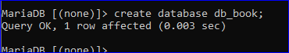

1. Create table

Table book_tb :

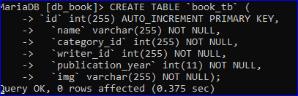

Table category_tb:

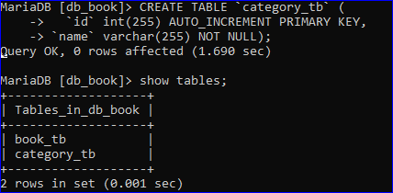

Table writer_tb;

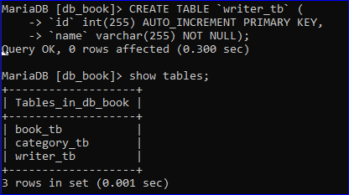

1. Insert data table

Insert data -> table book_tb:

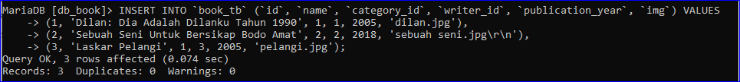

Insert data -> table category_tb:

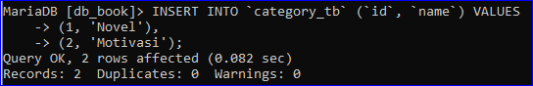

Insert data -> table writer_tb:

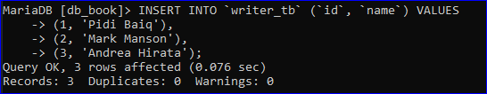

1. Tampilkan seluruh data table

Book_tb :

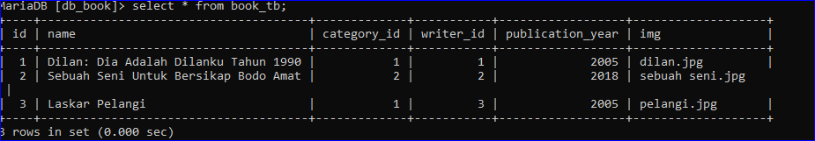

Category_tb :

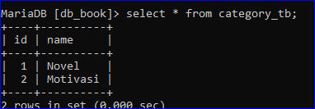

Writer_tb :

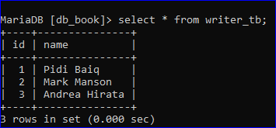

1. Tampilakn spesifik book beserta category maupun penulis

